IDEATION PHASE
Introduction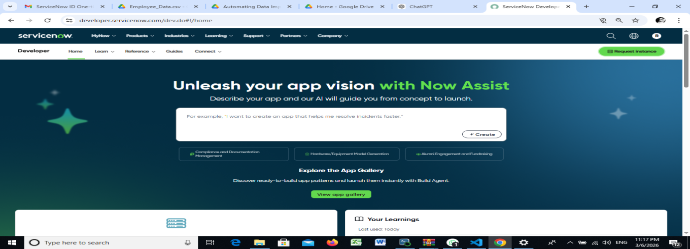

- In modern organizations, managing large volumes of employee and organizational data is a critical task. Many companies use digital platforms to store, manage, and process this information efficiently. ServiceNow is a powerful cloud-based platform that helps organizations automate workflows, manage IT services, and streamline business operations.
- One of the key challenges faced by organizations is importing large amounts of data from external sources such as Excel or CSV files into the system. Manual data entry can be time-consuming, inefficient, and prone to human errors. Therefore, automation becomes necessary to ensure data accuracy and efficiency.
- This project focuses on automating the data import process and establishing relationships between records using Import Sets and Dot Walking. Import Sets allow external data to be temporarily stored before being transformed into ServiceNow tables, while Dot Walking helps retrieve related information from other tables automatically. Together, these features enable efficient data integration and relationship mapping.

PROJECT OVERVIEW 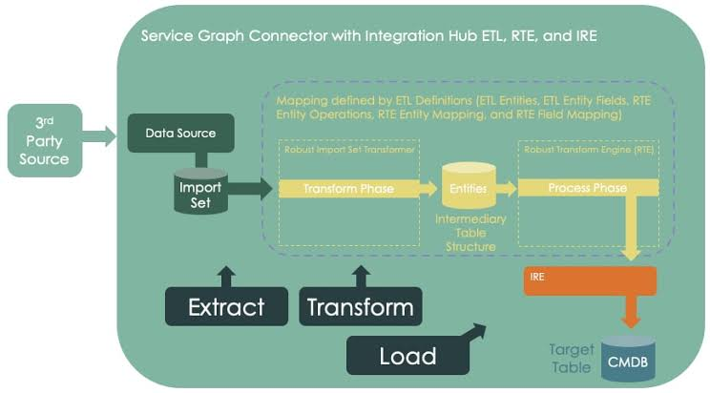
- The main objective of this project is to demonstrate how external user data can be automatically imported into the ServiceNow platform and how relationships between different records can be established.
- In many organizations, employee information such as name, department, email address, and manager details are maintained in spreadsheets. Instead of manually creating records in the system, this project uses Import Sets and Transform Maps to import the data automatically.
- Once the data is imported, Dot Walking is used to access related information from linked tables. For example, when a user is assigned to an incident, related details such as department, manager, and email can automatically appear in the form.
- This automation reduces manual work, improves data accuracy, and ensures that relationships between different records are maintained properly. The project demonstrates a practical approach to data integration within the ServiceNow environment.
PURPOSE
- The purpose of this project is to simplify and automate the process of importing external data into ServiceNow while ensuring proper relationships between different records.
- Organizations frequently receive data from external systems in formats such as Excel or CSV files. Entering this information manually into the platform can take a significant amount of time and may lead to errors such as incorrect department mapping or missing user details.
- By using Import Sets, the system can automatically upload and stage the data before transferring it into the appropriate tables. Transform Maps help map the fields from the imported data to the correct fields in the target table.
- Dot Walking is then used to retrieve related information from referenced tables. For example, when a user is selected in an incident form, the system can automatically display the user’s department, email address, and manager information.
- Overall, the purpose of this project is to improve efficiency, reduce manual effort, and ensure accurate data relationships within the ServiceNow platform.

PROBLEM STATEMENT
- Many organizations maintain their employee data in external files such as spreadsheets or databases. When this information needs to be entered into ServiceNow, manual data entry can become a major challenge.
- Manual processes are slow, inefficient, and prone to mistakes such as incorrect data entry, missing values, or duplicate records. Additionally, maintaining relationships between different records—such as linking a user to their department or manager—can become difficult when handled manually.
- Therefore, organizations require an automated solution that can efficiently import external data into ServiceNow and correctly map relationships between different tables.
- This project addresses this problem by using Import Sets to import external data and Transform Maps to map the fields accurately. Dot Walking is used to automatically retrieve related information from other tables, ensuring that relationships between records are maintained correctly.

EMPATHY MAP
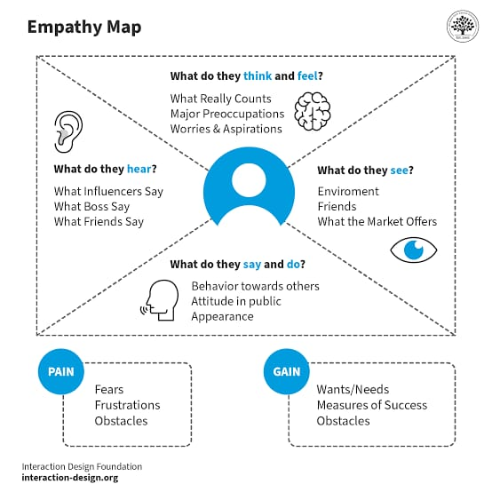

User Thinks
Users believe that data import processes should be simple, quick, and accurate. They expect the system to automatically handle large amounts of data without requiring manual corrections.
User Feels
Users feel frustrated when data import processes fail or when mapping errors occur. Incorrect relationships between records can lead to confusion and delays in workflow.
User Says
Users often express the need for automated tools that can quickly import external data and maintain proper relationships between different records in the system.
User Does
Users typically upload data files such as Excel or CSV documents into the system and then verify whether the records are imported correctly. They also check if the relationships between records are properly mapped.

BRAINSTORMING
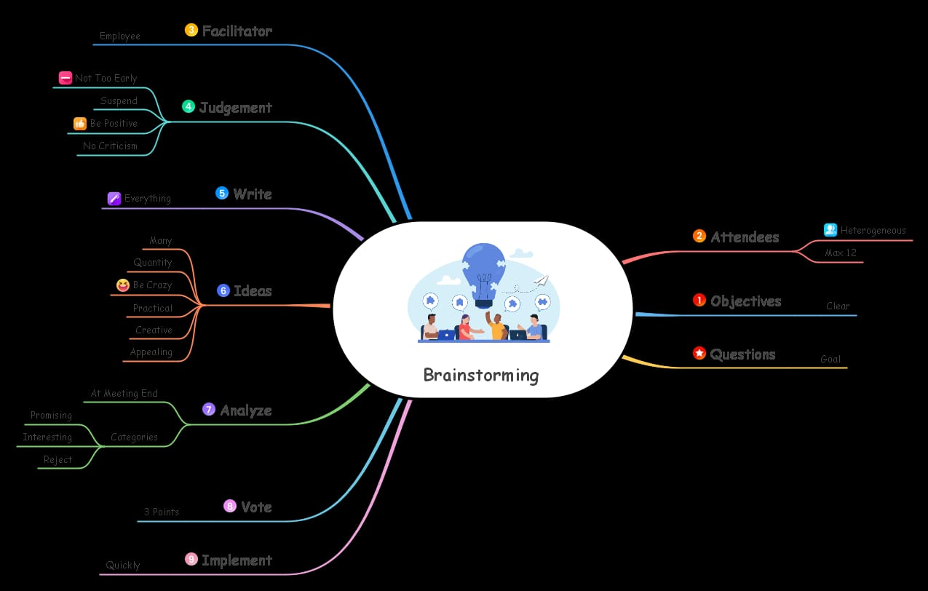

- During the ideation stage, several possible solutions were considered to address the problem of data import and relationship mapping.
- One approach was manual data entry, where users would manually create records in the system. However, this approach was inefficient and prone to errors.
- Another idea was automated data import using custom scripts. While this method could automate the process, it required advanced programming knowledge and additional maintenance.
- The third approach involved using Import Sets and Transform Maps provided by ServiceNow. This method allows external data to be staged and then transformed into target tables automatically.
- Finally, the concept of Dot Walking was considered to automatically retrieve related information from referenced tables. This approach simplifies data relationships and ensures that related details such as department, email, and manager are automatically displayed.
- After evaluating these options, the combination of Import Sets, Transform Maps, and Dot Walking was identified as the most efficient and practical solution.

SELECTED IDEAS
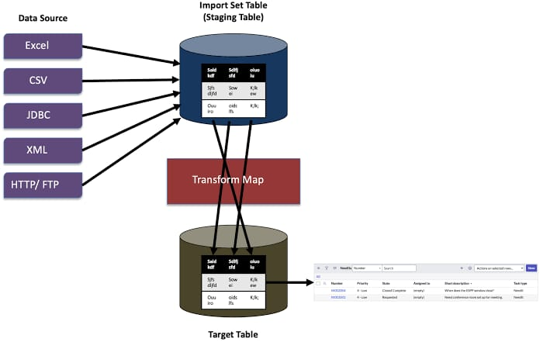

- The selected idea for this project is automating data import using Import Sets and establishing relationships between records using Dot Walking in ServiceNow.
- In this solution, external data files containing user information are uploaded into Import Sets. The data is then transformed into the target table using Transform Maps. Field mapping ensures that each data column is correctly transferred to the appropriate field in the system.
- Once the records are created, Dot Walking is used to retrieve related information from linked tables automatically. For example, when a user is assigned to an incident, the system automatically displays related details such as department, manager, and email address.
- This approach provides an efficient and reliable way to manage large volumes of data while maintaining accurate relationships between records.

